

PRD: MANAGER TASK BOARD TEMPLATE

**Proposed by,**

**Rithish sam m**

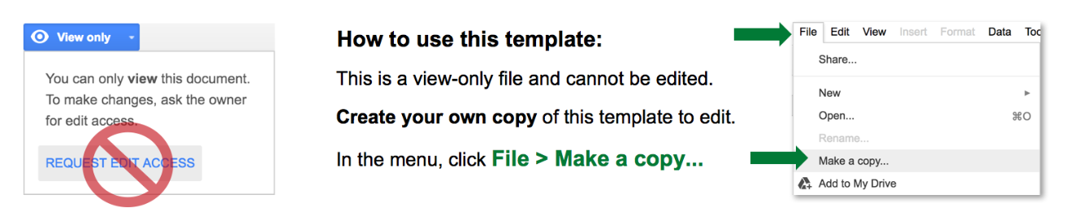

| **PRODUCT REQUIREMENTS TEMPLATE** | | | |
| --- | --- | --- | --- |
| PRODUCT TITLE | Project Phoenix: Customer Engagement Platform | | |
| AUTHOR | Sasha Petrov | | |
| PHONE | Phone | | |
| EMAIL |  | | |
| ADDRESS | 123 Main Street, Suite 125 | | |
| DATE | MM/DD/YY | | |
| OVERVIEW |  |  |  |
| Project Phoenix aims to develop a robust customer engagement platform catering to small and medium-sized businesses (SMBs). This platform will facilitate seamless interaction between businesses and their customers, offering features for messaging, customer support, and analytics. | | | |
| PRODUCT OBJECTIVES | |  |  |
| *Define the overarching objectives and goals the product aims to achieve. This section sets the context for the requirements that follow.* | | | |
| OBJECTIVE 1 | Enhance customer-business communication channels. | | |
| OBJECTIVE 2 | Provide a user-friendly interface for customer support queries. | | |
| OBJECTIVE 3 | Implement analytics tools for businesses to gain insights into customer interactions. | | |
| STAKEHOLDER IDENTIFICATION | |  |  |
| *List and describe the stakeholders involved in the project, specifying their roles, responsibilities, and interests in the product.* | | | |
| NAME | ROLE | RESPONSIBILITY | INTERESTS IN THIS PRODUCT |
| Melissa B. and Kiran G. | Marketing Team (Primary Users) | Provide insights into customer engagement needs. |  |
| Patricia H. and Jose P. | Development Team | Develop and maintain the platform. |  |
|  |  |  |  |
| FUNCTIONAL REQUIREMENTS | |  |  |
| *Detail the specific functionalities the product must have. Use user stories, scenarios, or use cases to describe how users will interact with the product and what the product needs to do.* | | | |
| Allow customers to initiate support tickets via chat or email. | | | |
| Provide a dashboard for businesses to track customer inquiries. | | | |
| Enable integration with social media platforms for direct messaging. | | | |
| NON-FUNCTIONAL REQUIREMENTS | |  |  |
| *Address aspects beyond specific features, such as performance, security, scalability, usability, compliance, and any technical constraints.* | | | |
| Response time for customer queries should be under 30 seconds. | | | |
| Platform should comply with GDPR regulations for data privacy. | | | |
| ASSUMPTIONS AND CONSTRAINTS | |  |  |
| *Identify any assumptions made during the requirement-gathering process and constraints that might impact the product's development or deployment.* | | | |
| **ASSUMPTIONS** | | | |
| The platform will be built on an existing cloud infrastructure. | | | |
| Assumption 2 | | | |
| Assumption 3 | | | |
| Assumption 4 | | | |
| **CONSTRAINTS** | | | |
| Initial development budget limited to $500,000. | | | |
| Constraint 2 | | | |
| Constraint 3 | | | |
| Constraint 4 | | | |
| DEPENDENCIES | |  |  |
| *Outline any external factors or dependencies that could affect the development or release of the product, such as third-party integrations or external services.* | | | |
| DEPENDENCY 1 | Integration with CRM software used by businesses. | | |
| DEPENDENCY 2 | Access to third-party API for social media integration. | | |
| ACCEPTANCE CRITERIA | |  |  |
| *Clearly define the conditions that must be met for each requirement to be considered successfully implemented and accepted.* | | | |
| CHAT FUNCIONALITY | Chat functionality should successfully handle 100 concurrent users. | | |
| CUSTOMER DATA | All customer data stored must be encrypted using AES256. | | |
| RISK ANALYSIS | |  |  |
| *Assess potential risks that could impact the project's success and detail mitigation strategies or contingency plans.* | | | |
| RISK | | MITIGATION | |
| Potential delays due to third-party API changes. | | Have backup options for social media integration. | |
| Regulatory changes impacting data privacy laws. | | Regular compliance reviews and quick adaptation. | |
|  | |  | |
| PRIORITY EFFORT | |  |  |
| *Assign priority levels and estimate the effort required for each requirement to assist with project planning and resource allocation.* | | | |
| REQUIREMENT | PRIORITY LEVEL | ESTIMATED EFFORT REQUIRED | |
| Requirement 1 | **High** | Estimated effort - 4 weeks. | |
| Requirement 2 | **Medium** | Estimated effort - 6 weeks. | |
| Requirement 3 | **Low** | Estimated effort - 8 weeks. | |
|  | **High** |  | |
| VERSION HISTORY AND CHANGE LOG | |  |  |
| *Maintain a record of revisions, updates, and changes made to the document to track the evolution of requirements.* | | | |
| VERSION | EDITS COMPLETED BY | DATE | DESCRIPTION OF EDIT |
| 1.00 | Sasha P. | MM/DD/YY | Initial draft |
| 1.10 | Sasha P. | MM/DD/YY | Added stakeholder details |
| 1.20 | Sasha P. | MM/DD/YY | Included risk analysis |
|  |  | MM/DD/YY |  |
|  |  | MM/DD/YY |  |
| VISUAL AIDS |  |  |  |
| Incorporate diagrams, wireframes, mock-ups, or prototypes to visually represent the product's expected look and feel, enhancing understanding and clarity. | | | |